**Chem 1984 Marathon problem #4**

**Mystery Compound**

**Due Monday 30 September 2013 by 4 PM**

**(no electronic submissions will be accepted)**

**7 points**

I am a compound composed of two elements. I can’t be burned. If introduced into your body I eviscerate its blood cells. One of my elements is from group 7A. The other is from group 5A. A collection of 200 molecules of me weighs 5.645 x 10-8  pg. One molecule of me contains 6 atoms. When 2 molecules of me decompose together, 5 molecules of a toxic yellow, green homonuclear diatomic gas form along with a shiny grey solid at room temperature.

1. Who am I ? (Show work or you receive no credit.)
2. What is the balanced reaction that forms the toxic green gas and shiny grey solid ?

Note: some trial and error and `out of the box’ reasoning is needed here.  
[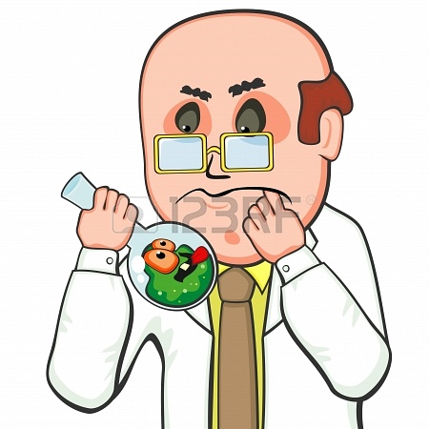](http://www.google.com/url?sa=i&source=images&cd=&cad=rja&docid=KiJwowb7XXYADM&tbnid=ec0_ulfavSStiM:&ved=0CAgQjRwwADjkAQ&url=http://www.123rf.com/photo_15366091_aggressive-mutant-flower-biting-finger-of-scientist.html&ei=Q6g7Urn0M9GbqwHh7YCIDA&psig=AFQjCNFGtoBGULBXKoZ-V11XtyXWu1wH7Q&ust=1379727811904793)