**Chem 1984 Marathon problem 7:**

**A Salt on your brain**

**Due Monday 28 October 2013 by 4 PM**

**(no electronic submissions will be accepted)**

**(5 points)**

Using just the atomic radii for Na+ and Cl- quoted in your text( 95 and 181 pm respectively) and that the NaCl structure is fcc (see below):

1. Estimate the lattice constant L (in pm) of the `unit cell’ shown here. (hint: Na+ and Cl- space-fill the cell with the above radii as shown in the figure on page 2 herein.)1 2 pts

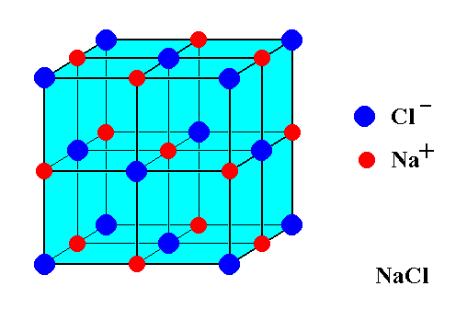

L

The sum of the diameters of NaCl on one side constitute an estimate of the lattice spacing = 2*(rCl + rNa‑)= 2*(181+95) pm

=>L=552 pm (vs. 564.02 pm experimental)

1X-ray diffraction studies place the lattice constant of NaCl at 564.02 pm

2 Note: the actual density of NaCl is 2.16 g/cm3

1. Given that each cell as drawn above contains 4 atoms of Cl and 4 atoms of Na, estimate the density of NaCl in g/cm3 4 pts

Each cell has a volume V= L3 = (5.52*10-8 cm)3  =1.68*10-22 cm3

4 Na + 4 Cl atoms have a mass m= 4*(22.99 +35.45 amu)

where 1 amu =1.66*10-24g

=>m =4*58.44*1.66*10‑24 g

=3.88*10-22 g

* d = m/V = 3.88*10-22 g/1.68*10-22 cm3 = 2.31 g/cm3

vs. 2.16 g/cm3 observed.

Actual space-filled appearance of NaCl

L

