**Chem 1984 Marathon problem 7:**

**A salt on your brain**

**Due Monday 28 October 2013 by 4 PM**

**(no electronic submissions will be accepted)**

**(5 points)**

Using just the atomic radii for **Na+** and **Cl-** quoted in your text ( 95 and 181 pm respectively) and that the NaCl structure is fcc (see below):

1. Estimate the lattice constant L (in pm) of the `unit cell’ shown here. (hint: **Na+** and **Cl-** space-fill the cell with the above radii as shown in the Figure on page 2 herein.)1 1 pt

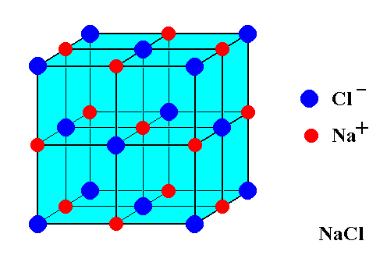

fcc structure for **NaCl**

L

1. Given that each cell as drawn above contains **4** atoms of **Cl** and **4** atoms of **Na**, estimate the density of NaCl in g/cm3 using your estimate of L. 4 pts

1X-ray diffraction studies place the lattice constant of NaCl at 564.02 pm

2 The actual density of NaCl is 2.16 g/cm3 at 20o C

Actual space-filled appearance of **NaCl**

L

