Chem 1984 Marathon problems 5.1 and 5.2
Due Wednesday 9 October 2013 by 4 PM
(no electronic submissions will be accepted)
(4 points/problem) *2 problems = 8 points

Problem 4.1 (4 points)
A metal, M, was converted to the chloride MCl₂ . A solution of this chloride is treated with silver nitrate to give silver chloride crystals which were filtered from solution. The balanced reaction is:

MCl₂ (aq) +2AgNO₃(aq) --------> M(NO₃)₂ (aq) + 2AgCl(s) .

If 2.4434 g of metal M gave 7.964 g of silver chloride, what is the atomic mass of the metal ? What is the metal ?
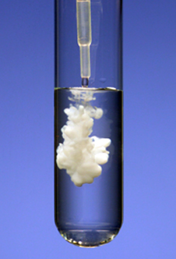
Answer
MW of AgCl= 107.8+35.45=143.25 g/mol
- 7.964 g AgCl/143.25 g mol⁻¹ =0.05556 mol
- Since mol AgCl=mol Cl and mol M/mol Cl= ½
- Mol M reacted= ½ *0.05556=0.0278
Atomic wt = grams M/mol M= 2.4434/0.278
=87.9 g/mol => Sr

Problem 4.2 (4 points)
A puzzled chemist colleague gives you his notes from a recent set of experiments he’s run on a red colored sample of copper oxide.
His notes are reproduced below:
a)Mass of red colored copper oxide =100.00 g
b)Mass of black colored copper oxide formed after heating the above
red-colored sample in oxygen =109.43 g
c) Mass of H₂O collected when treating the red-color sample above
with hot H₂ gas¹: =24.77 g
¹pure copper metal also resulted from this treatment.
ANSWER:
Mol H₂O = 24.77/18 = 1.376 = mol O in 100 gram red-colored copper oxide sample
1.376 mol O * 16 g O/mol = 22.018 g O in red colored oxide => grams Cu = 100-22.018=77.98 g
Thus, the moles Cu in the red colored sample = 77.98/63.54=1.227
Red colored oxide stoichiometry: Cu_{1.227}O_{1.376} = Cu_{1.0}O_{1.12} not even numbered ?
Also…red copper oxide supposedly is Cu₂O
Black colored compound contains 9.43 g more O=> 9.43/16=0.589 mol O
The black colored compound thus contains 0.589+1.376 mol O=1.965 mol O
Black colored oxide stoichiometry= Cu_{1.227}O_{1.965} = Cu_{1.0}O_{1.60} again not quite stoichiometry
Also…black copper oxide is supposedly CuO

What are the empiric formulas for the black and red copper oxide compounds and why is your chemist colleague puzzled ?
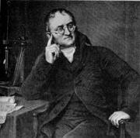

Duh ??
