Chem 1984 Marathon problems 4.1 and 4.2
Due Wednesday 9 October 2013 by 4 PM
(no electronic submissions will be accepted)
(4 points/problem) *2 problems = 8 points

Problem 4.1 (4 points)
A metal, M, was converted to the chloride MCl₂ . A solution of this chloride is treated with silver nitrate to give silver chloride crystals which were filtered from solution. The balanced reaction is:

MCl₂ (aq) +2AgNO₃(aq) --------> M(NO₃)₂ (aq) + 2AgCl(s) .

If 2.4434 g of metal M gave 7.964 g of silver chloride, what is the atomic mass of the metal ? What is the metal ?
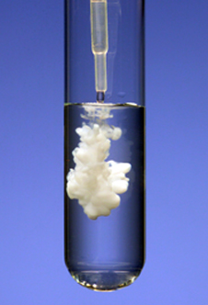

Problem 4.2 (4 points)
A puzzled chemist colleague gives you his notes from a recent set of experiments he’s run on a red colored sample of copper oxide.
His notes are reproduced below:
a)Mass of red colored copper oxide =100.00 g
b)Mass of black colored copper oxide formed after heating the above
red-colored sample in oxygen =109.43 g
c) Mass of H₂O collected when treating the red-color sample above
with hot H₂ gas¹: =24.77 g
¹pure copper metal also resulted from this treatment.

What are the empiric formulas for the black and red copper oxide compounds and why is your chemist colleague puzzled ?
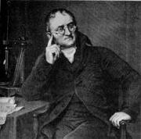

Duh ??
