**About your Fall 2013 Chem 1984 Instructor**

[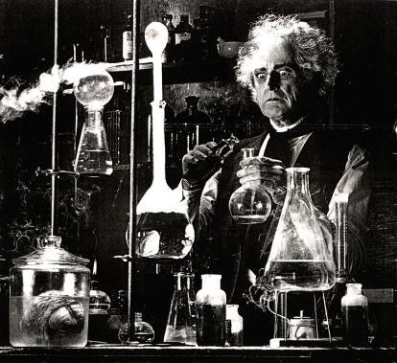](http://www.google.com/url?sa=i&rct=j&q=&esrc=s&frm=1&source=images&cd=&cad=rja&docid=1JxbeJ_ExTzUHM&tbnid=92ARRh24CgPwnM:&ved=0CAUQjRw&url=http://scientopia.org/blogs/drugmonkey/2013/03/01/it-is-always-the-chemists/&ei=RsoUUuPpEJiw4APU4IHgDA&bvm=bv.50952593,d.aWc&psig=AFQjCNHmZlSMoVmxIhOPitBUH7_05xVblw&ust=1377180534768593)

Dr. Jerry Fong -aka `Doc’ is short, sardonic and sick. As a child he contracted a singular case of chemical geekiness for which no cure was found. Even after nearly 40 years as a professional chemist, his fever still spikes dangerously when he intimately massages and strips FTIR transmission curves, mass spectra and titrimetric data for their juicy bits.

The illness began at age 13 from a homemade chemistry kit given to him by his Dad. The infection spread alarmingly while he earned a B.Sc. with honors from the University of California, Berkeley’s College of Chemistry. There, the not-yet Doc reveled in measuring heat capacities of weird rocks at the Giauque Low Temperature Lab at 2 AM on a Friday night, when every one else was looking for nooky.

Truly serious metastasis occurred while he earned both M.Sc. and Ph.D. in Physical Chemistry from the University of Michigan, Ann Arbor. At the U of M, the almost Doc spent most of his twenties delightedly exploring molecular structure and chemical kinetics studies on useless, explosive and poisonous volatile molecules with microwave spectroscopy. By the end of his post-doctoral stay at Purdue, where he carried on a frankly illicit affair unraveling the path of in vitro photosynthesis of chlorophyll using electron spin resonance, his complete, permanent sick-puppyhood was assured.

He then joined a gaggle of fellow sickies at Corning Incorporated and scarily deepened the dark depths of his affliction for 11.9 years as a staff research scientist. There he bred patents (six) and molested glass, semiconductors, solid state diffusion phenomena and high temperature electrochemistry on the company dime. In 1993 he slithered to Alfred State to spread his incurable disease as a chemistry teacher. He’s been there ever since, a virulent vector of his malady, spreading it as instructor of every chemistry course taught on campus except Biochemistry.

Somewhere along the way, Doc also managed to get married to a lovely, honest-to-god woman with a high pain threshold, raise two beautiful daughters (now older than most students at Alfred) and entirely pay for a crumbling hovel in the country, all of which, he has determined from extensive, calibrated measurement, he also loves (except for the paying part.)

Doc’s rare moments of remission find him trying to master Bach’s Two Part Inventions (all but #12 in A major appear in the bag) and writing poetry (yes, Virginia, poetry)-which FYI, he has had published in several questionable magazines. He does yoga 4 times a week because his wife makes him.

Finally, Doc is probably the only person on campus who’s genetically incapable of working a smart phone. However, he has read every single novel by Sinclair Lewis (except **Cass Timberlane**), knows 5 really great ways to synthesize crystal meth and has watched every single episode of the original **Star Trek** at least 3 times each. (FYI-he’s also seen all of **Next Generation**, **Voyager**, **Deep Space Nine** and **Enterprise**.) Press his buttons and he’ll rant about all of it.

Don’t beam him up, Scottie!